OptiCrop: Smart Agricultural Production Optimization Engine
Final Project Report
Project Title
OptiCrop: Smart Agricultural Production Optimization Engine

1. Abstract
The OptiCrop Smart Agricultural Production Optimization Engine is a machine learning–based web application designed to recommend the most suitable crop based on soil nutrients and environmental conditions. The system uses historical agricultural data containing Nitrogen (N), Phosphorus (P), Potassium (K), temperature, humidity, pH, and rainfall values. Multiple machine learning algorithms were evaluated, and the best-performing model was deployed through a Flask backend API with a responsive web interface.
The project demonstrates the complete lifecycle of a machine learning application, including data preprocessing, exploratory data analysis, model training, evaluation, deployment, and user acceptance testing.

2. Introduction
Agriculture plays a critical role in food security and economic development. Farmers often face challenges in selecting the most appropriate crop for their land due to varying soil and weather conditions. The OptiCrop system addresses this problem by providing data-driven crop recommendations using machine learning techniques.

Objectives
Core goals
- Build a machine learning model for crop recommendation.
- Develop a Flask-based prediction API.
- Create a user-friendly web interface.
- Validate the system through functional and user acceptance testing.

3. Problem Statement
Farmers may not always have access to expert agricultural advice. Incorrect crop selection can lead to reduced yield and financial loss. Therefore, an intelligent recommendation system is required to assist in selecting the optimal crop based on soil and environmental parameters.

4. Scope of the Project

Included
Implemented
- Soil data analysis
- Machine learning model training
- Crop prediction API
- Web-based dashboard
- Input validation
- Testing and evaluation

Future Scope
Planned
- Weather API integration
- IoT sensor connectivity
- Cloud deployment
- Mobile application support
- Multilingual interface

5. System Architecture
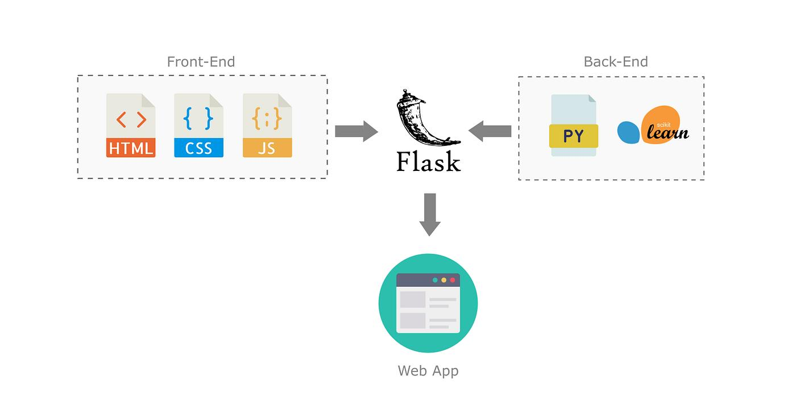
Architecture Flow
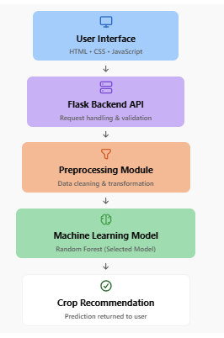
6. Technology Stack
Layer | Technology
Frontend | HTML5, CSS3, JavaScript
Backend | Flask (Python)
Machine Learning | Scikit-learn
Data Processing | Pandas, NumPy
Model Storage | Pickle (.pkl)
Development Tools | Jupyter Notebook, VS Code
Dataset | CSV File

7. Machine Learning Implementation

Algorithms Evaluated
4 supervised + 1 unsupervised
Logistic Regression
K-Nearest Neighbors (KNN)
Decision Tree
Random Forest
K-Means Clustering (EDA)

Selected Model
Best performance
Random Forest Classifier
Chosen for highest prediction accuracy and stability
Production model

8. Data Preprocessing
- Handled missing values
- Checked outliers in N, P, and K values
- Normalized numeric ranges
- Analyzed feature correlations
- Prepared training and testing datasets

9. Functional Testing Summary

Functional Test Results
All passed
Metric | Result
Total Test Cases | 15
Passed | 15
Failed | 0
Success Rate | 100%

Key Functional Tests
Input validation
Boundary value testing
API request/response testing
Prediction generation
Error handling verification

10. User Acceptance Testing (UAT) Summary

User Acceptance Results
Approved
Metric | Result
Total Test Cases | 10
Passed | 10
Failed | 0
Success Rate | 100%

User Feedback
Category | Feedback
Ease of Use | User-friendly interface
Performance | Fast prediction response
Accuracy | Relevant crop recommendations
Navigation | Easy to operate

11. Results and Achievements

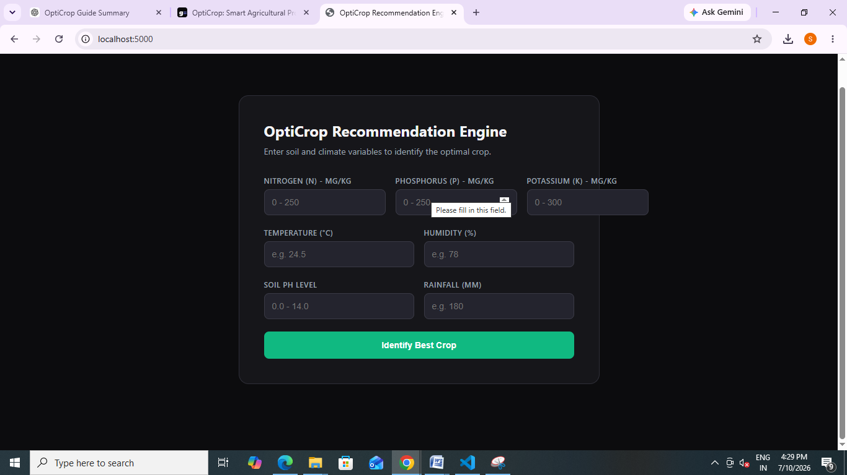
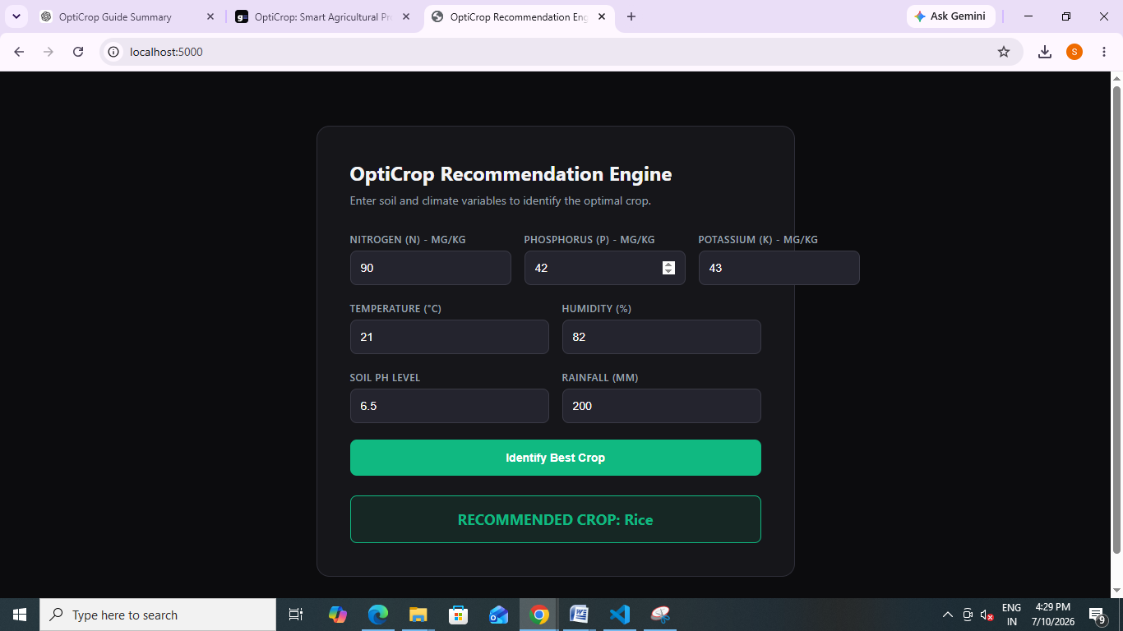

Dataset Processed
100%
All records cleaned and prepared
Models

Algorithms Compared
4
Evaluated for performance
Testing

Functional Tests Passed
15 / 15
Zero failures recorded
UAT

User Acceptance Passed
10 / 10
Approved for deployment

12. Future Enhancements
- Integrate live weather forecasting APIs
- Support regional languages
- Deploy on cloud platforms
- Add mobile application support
- Connect with IoT soil sensors
- Provide fertilizer recommendations
- Generate crop yield predictions

13. Conclusion
The OptiCrop Smart Agricultural Production Optimization Engine successfully demonstrates the application of machine learning in agriculture. The system preprocesses soil and environmental data, evaluates multiple algorithms, deploys the best-performing model through a Flask API, and provides real-time crop recommendations through a web interface.
Functional testing and User Acceptance Testing confirmed that the application meets its intended requirements with a 100% test success rate. The modular architecture allows future expansion with weather APIs, cloud deployment, IoT integration, and mobile accessibility, making OptiCrop a scalable and practical solution for intelligent agricultural decision-making.


